**Superstore Sales Data Analysis**

**ZITING LIANG**

* **Abstract**

With growing demands and complicated competitions in the supermarket and grocery category, More and more brands of supermarket or grocery store are starting to use data analysis to evaluate their sales performance, predict the sales and do customers segmentation. They would like to understand which products, regions, categories and customer segments they should target or entry.

This is a dataset of a superstore giant company, which are total 9994 observations and 21 variables in the original dataset, including both categorical and numeric variables such as Order.Date, Customer.ID, State, Sales, Profit, and Discount. Since some variables are useless for the analysis or overlapped, we selected 12 key variables to do the analysis. In addition, there are no blanks in the original data, therefore we can start to do some descriptive statistics and see what we can do in this dataset.

* **Descriptive statistics, appropriate graphs and tables**

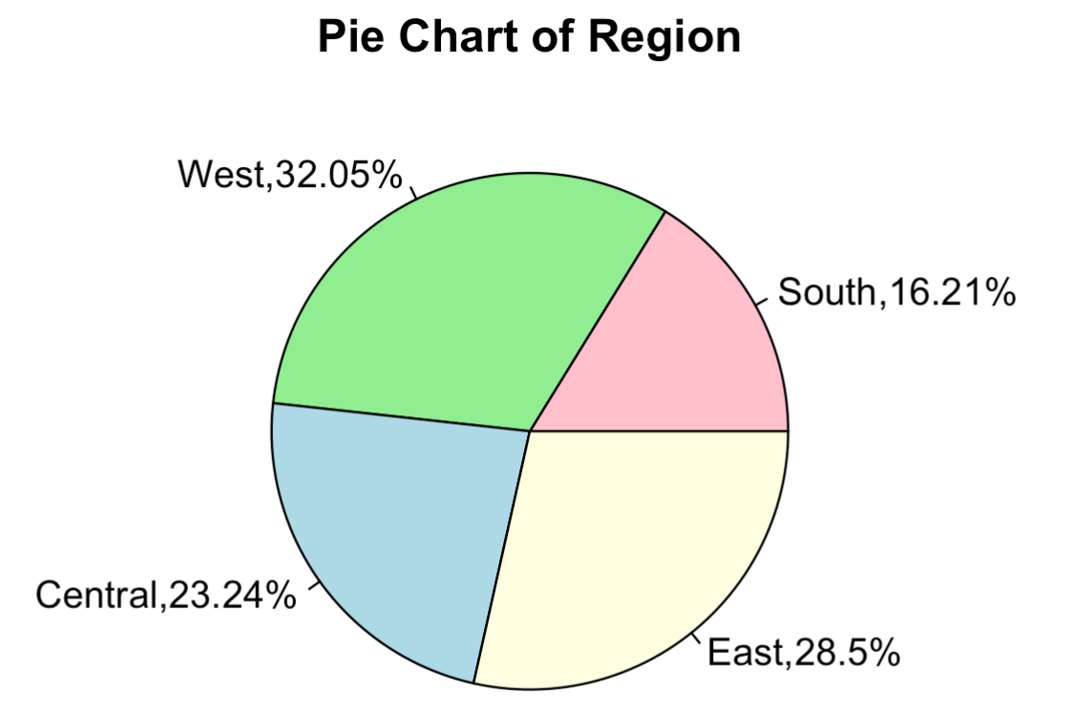

According to the Pie chart, we can see the customers of the superstore are very averagely distributed in each regions. West is little higher than other region, which is 32.05%.

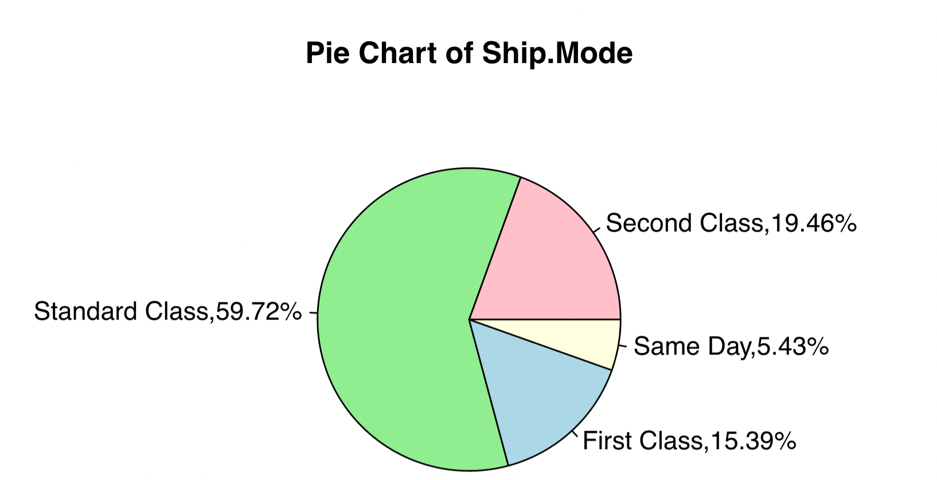

Obviously, most of the orders are shipped by standard class, which is 59.72%.

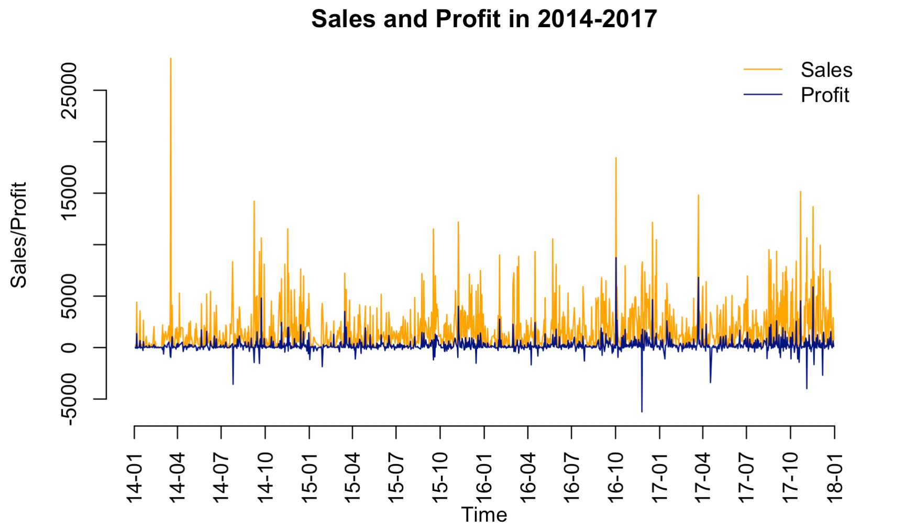

As the chart shows, the Sales and profit during 2014 -2017 is not very stable, and Profit is much lower than Sales.

* **Hypotheses and other analysis**
  + **hypotheses**

Based on the descriptive statistics, we came up three hypotheses.

We want to know what variables have effect on Sales and we want to figure out a great model to predict future sales by using multiple linear regression and generalized linear model. Here is our hypothesis:

* + - H0: The selected 11 variables have no impact on Sales
    - H1: At least one of the selected 11 variables have impact on Sales.

First of all, we did Q-Q plots to see the distribution of the numeric variables:

From the Q-Q plots, we can see that Sales is not normal distributed. We think the reason is that the scale of Sales and Profit is much bigger than other variables. Because we recode those categorical variables to numeric variables, therefore they show different levels to Sales and Profits. In order to run a better regression model, we did a normalization for Profit and took logarithm for Sales.

Distribution of Sales and Profits before Scaled

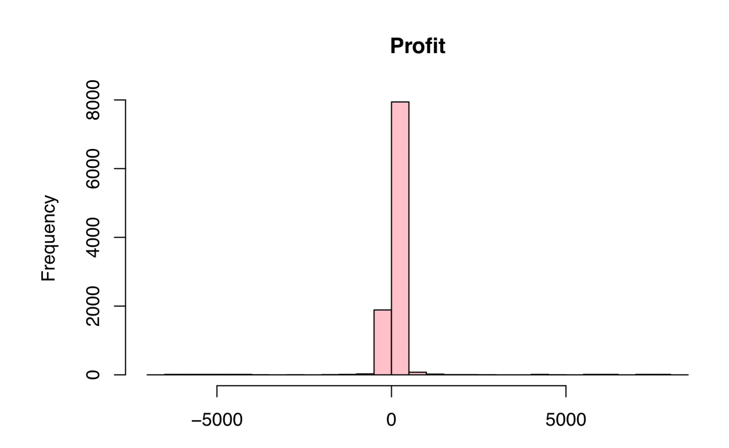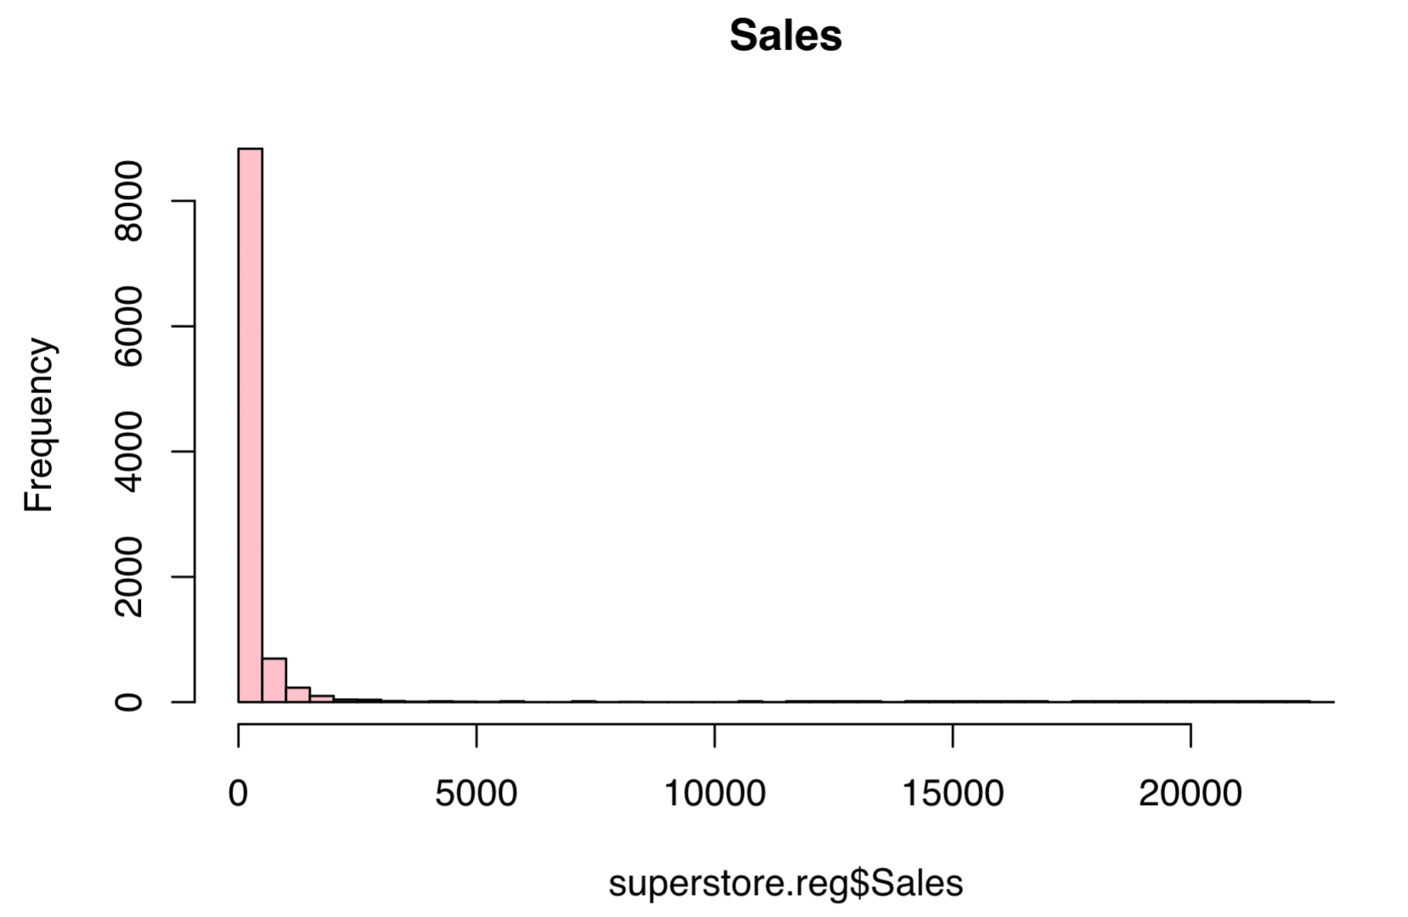Distribution of Sales and Profits before Scaled

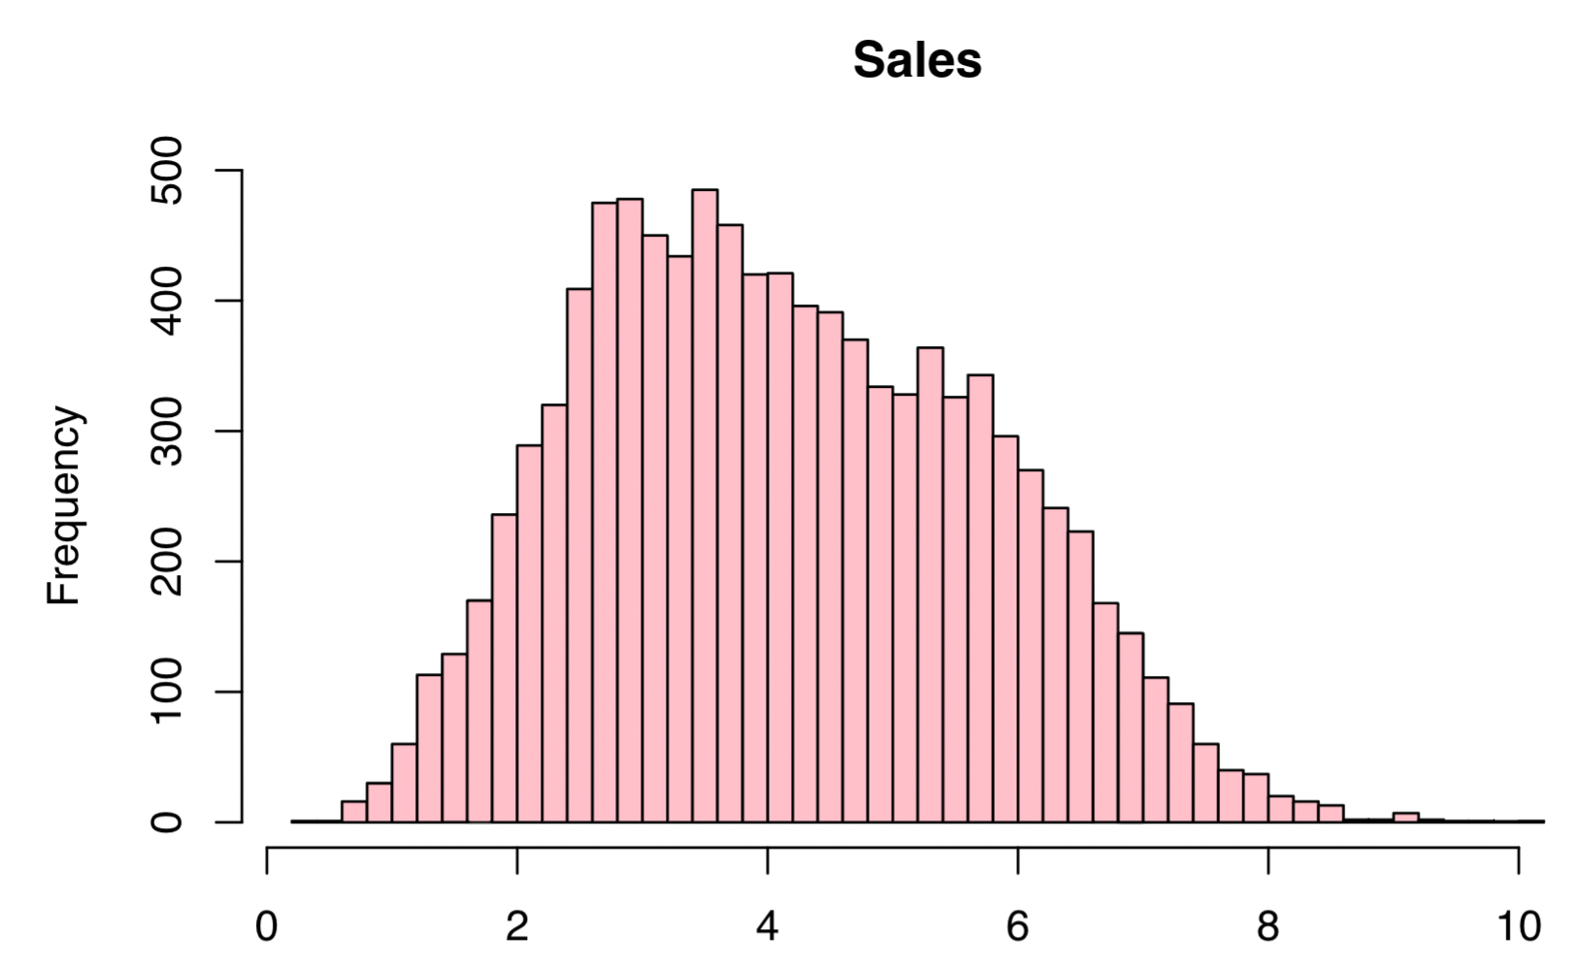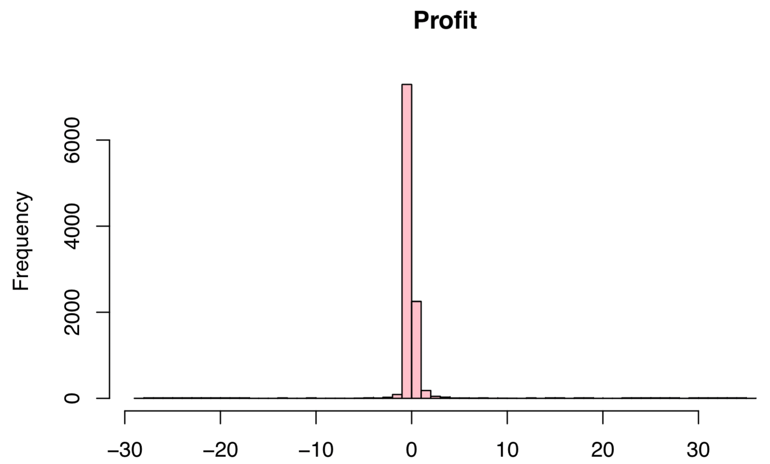

Now we can do a regression model

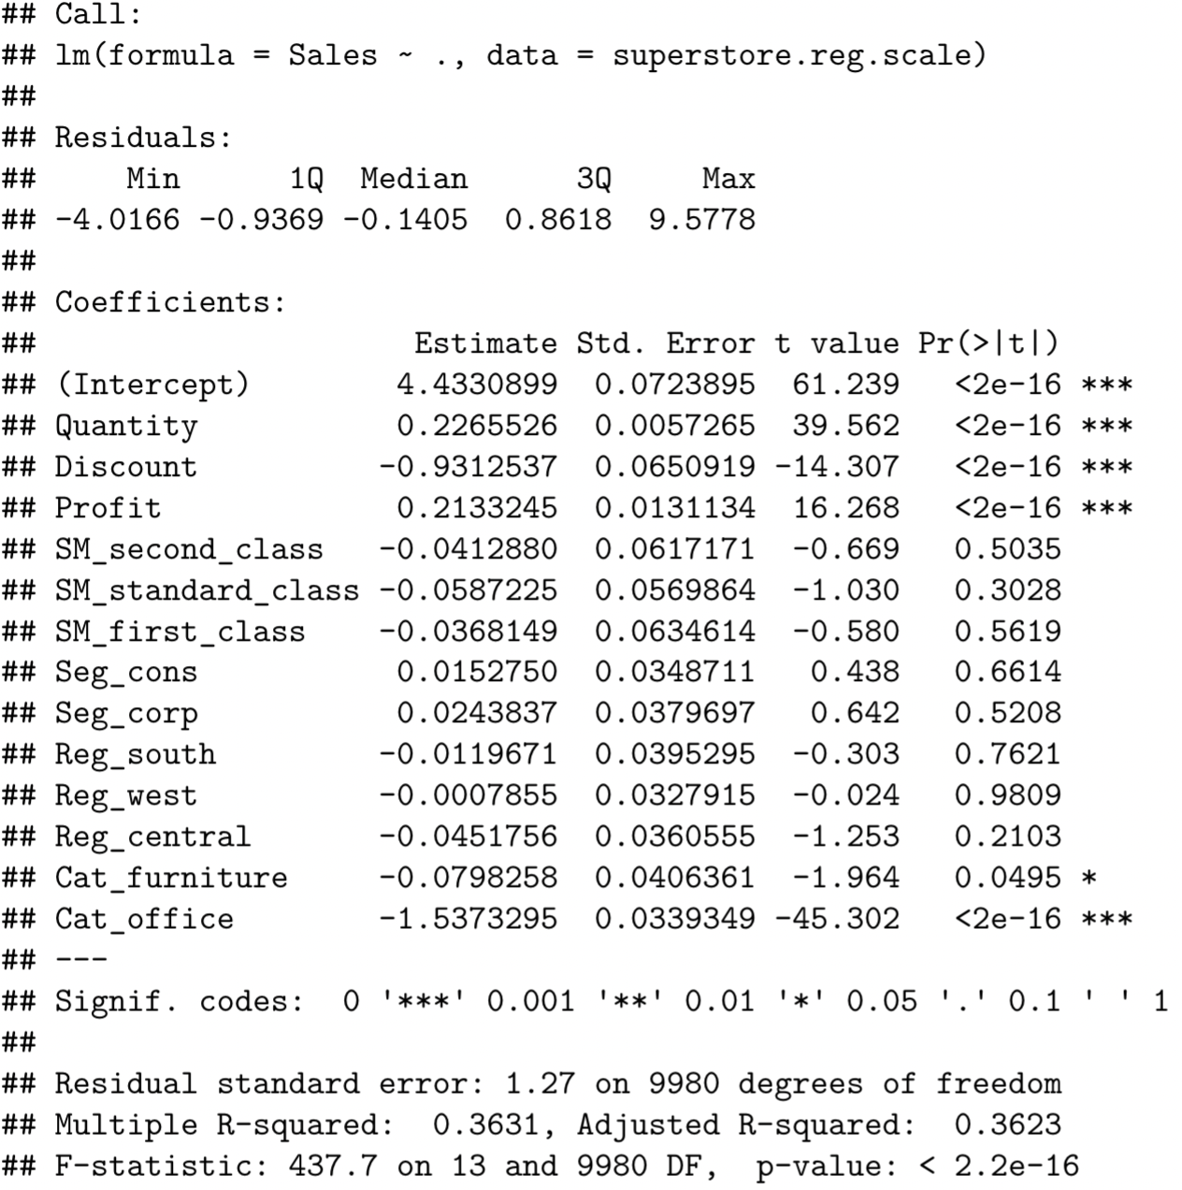

From the regression model, we can see that the model is not very well since most of the variables are not significant. Therefore, we did a correlation on those variables.

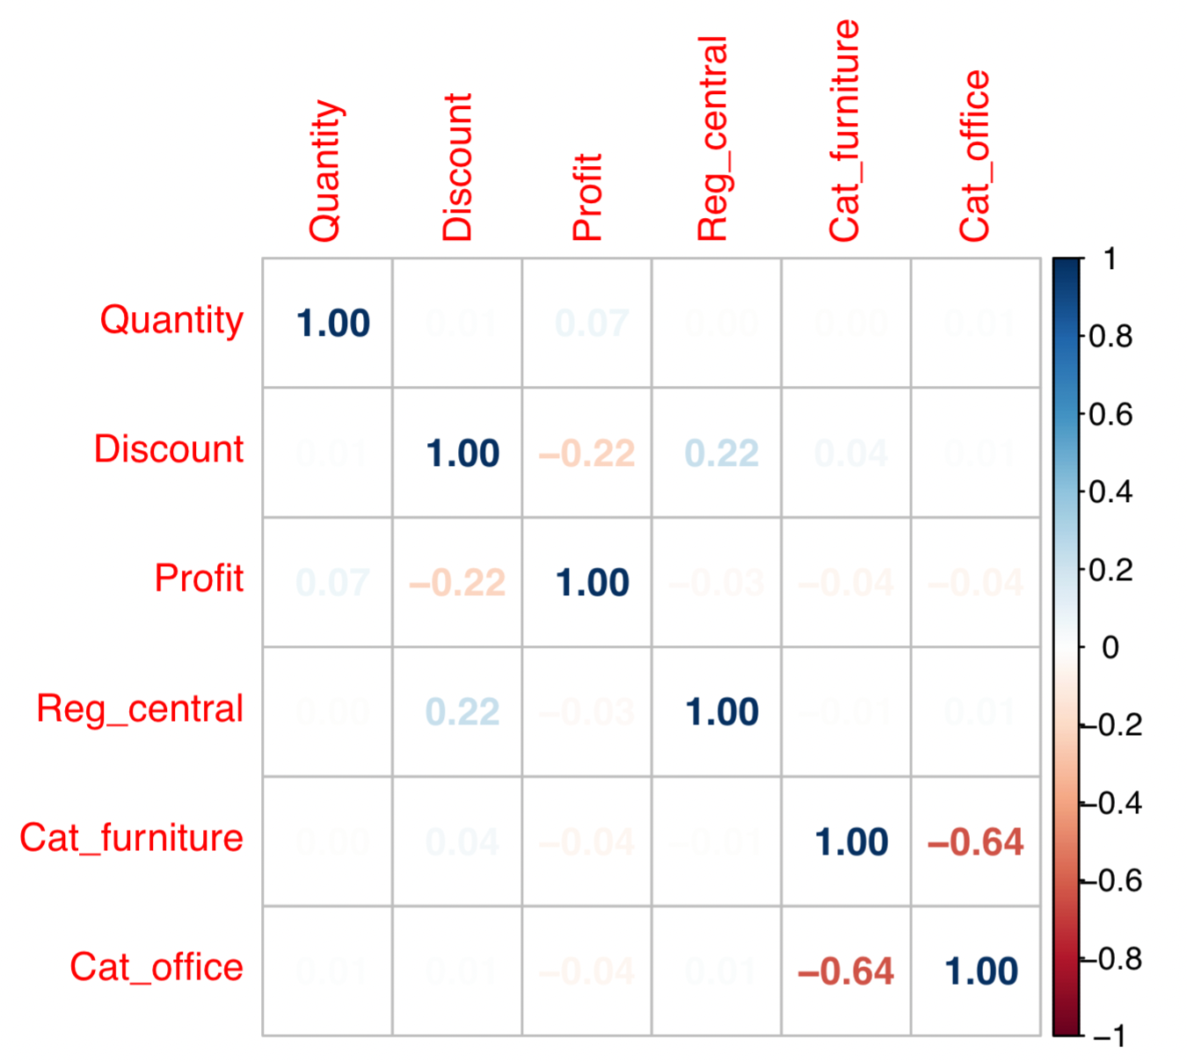

From the correlation plot, we can see that Cat_furniture and Cat_office is highly correlated. After that, we did a Stepwise linear regression to see which variables is better for the model.

Though it shows Cat_furniture is better in the model, we still put Cat_furniture and Cat_office separately into the models and rerun them.

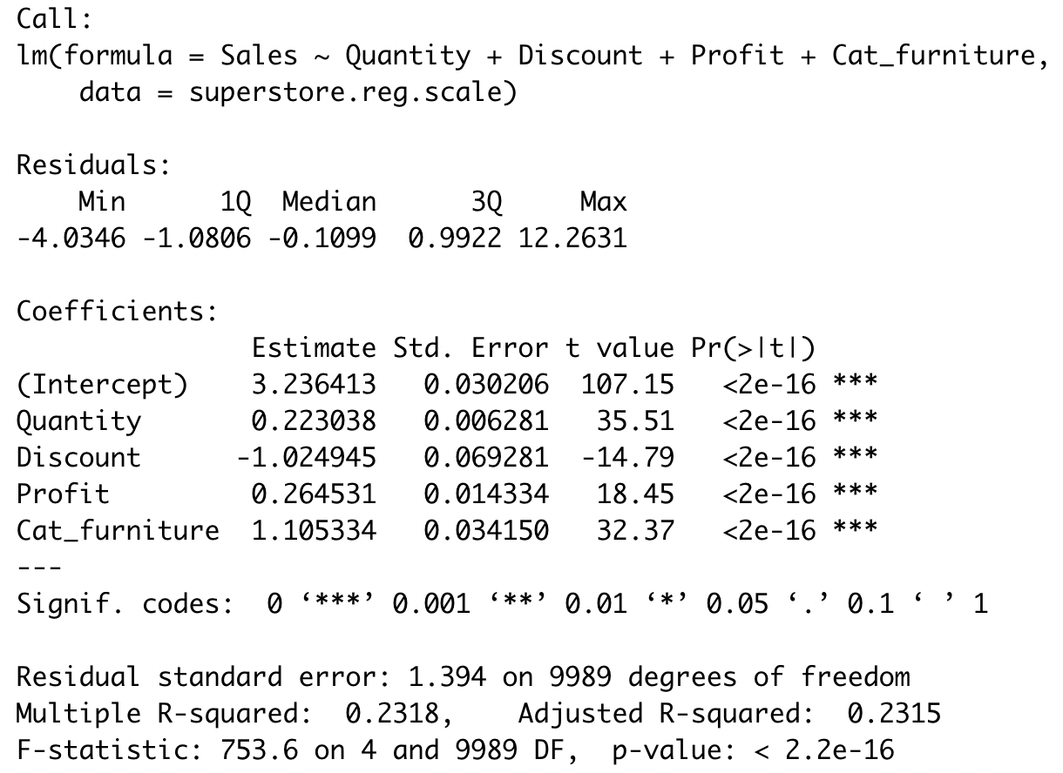

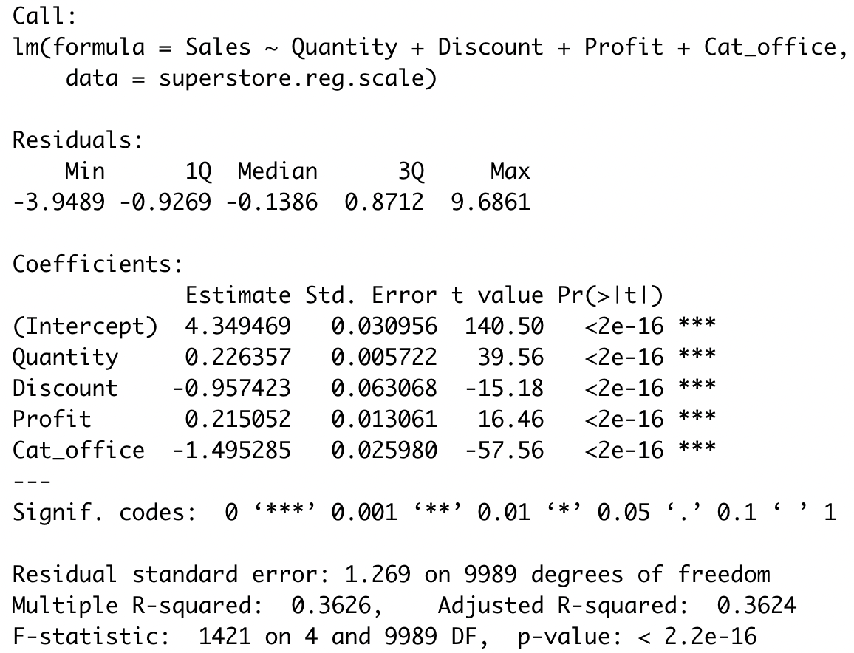

As we can see obviously, the later one is better, since it has higher R-squared and lower Residual standard error. The variables are all significant. This is the final regression model for Sales. And also, we made a regression tree:

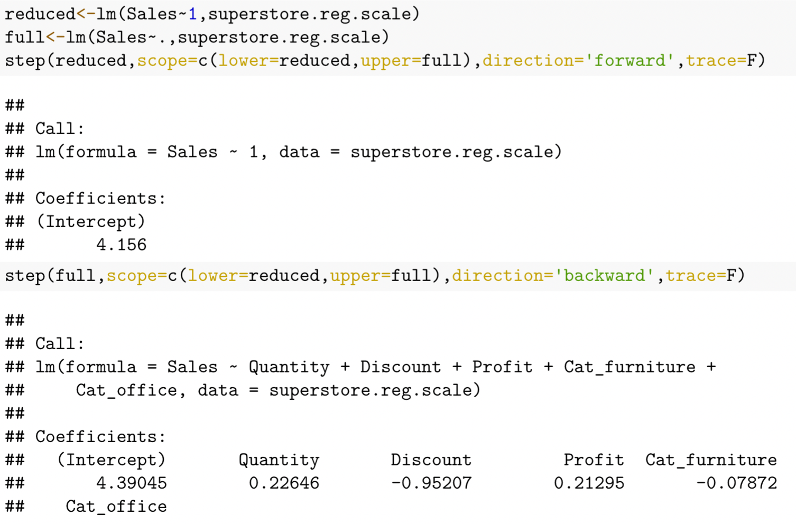

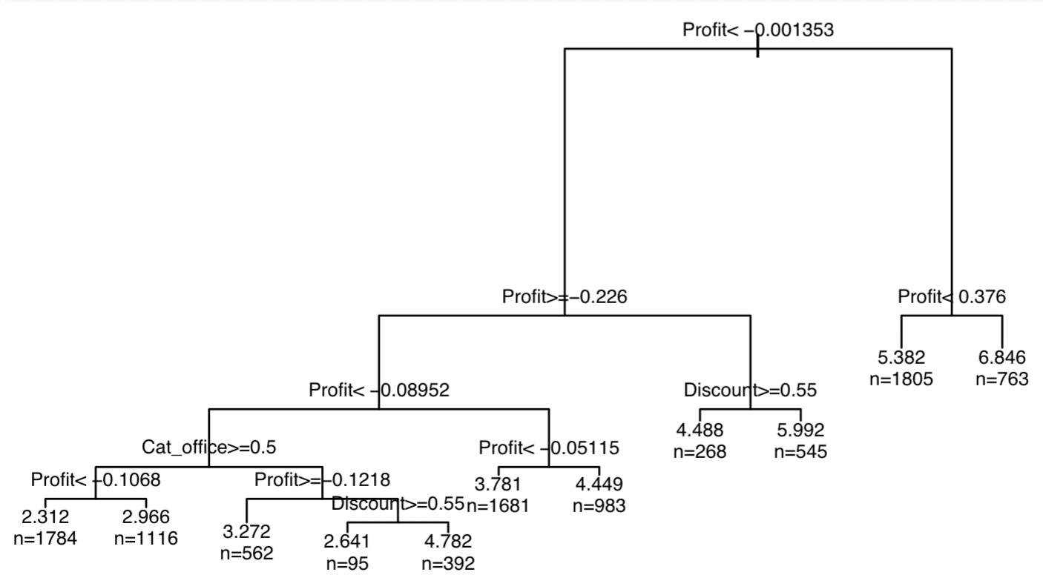

Since we got the final regression model, we figured that coefficient of Discount and Profit are high, we started to think about whether Discount will have impact on Sales and Profit. So we did an ANCOVA analysis. Here are two hypotheses for doing an ANCOVA:

* + - H0: There is no relationship between Sales and Discount

H1: There is a relationship between Sales and Discount.

* + - H0: Different level of discount doesn’t form an interaction between Sales and Profit.

H1: Different level of discount form an interaction between Sales and Profit.

First, we transferred Discount to a categorical variable with three levels: DiscountNo,DiscountLow and DiscountHigh.

After that, we did a simple summary that how different level of discount may effect the Profit.

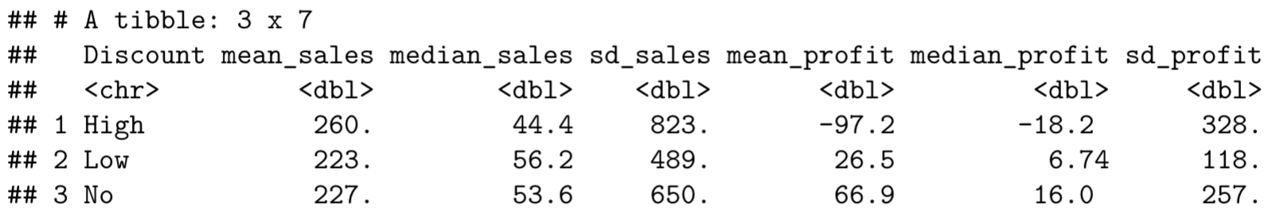

From the table, we can see the high discount may bring low profit. However, most of the people think that higher discount will sell more product, therefore it can make a higher profit. In the following steps of ANCOVA, we will know what the reason is.





The p-value is 0.136 that is greater than 0.05, so Discount and Sales are independent to each other.

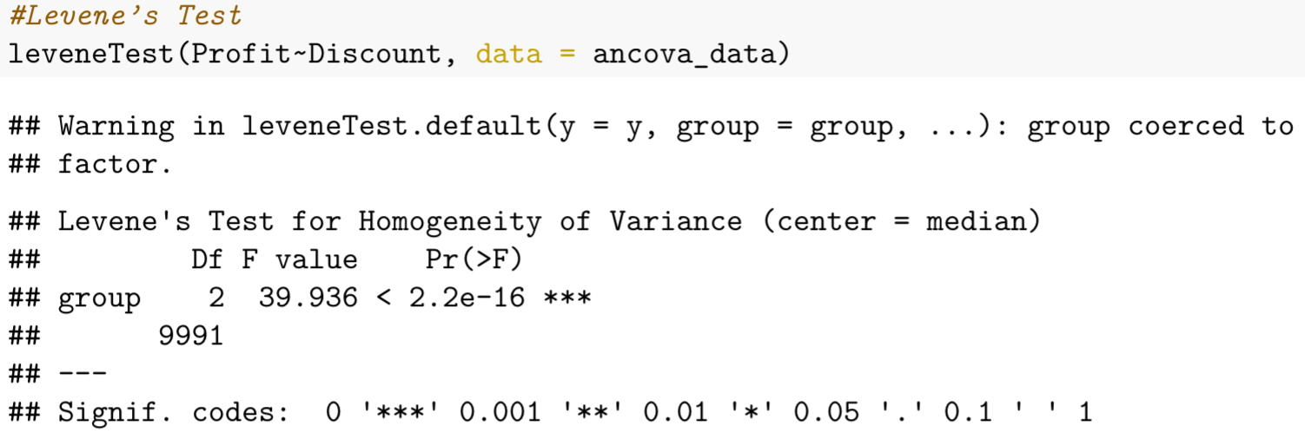

The p-value of the test is 2.2e-16, which indicates that the variances among the groups are not equal.

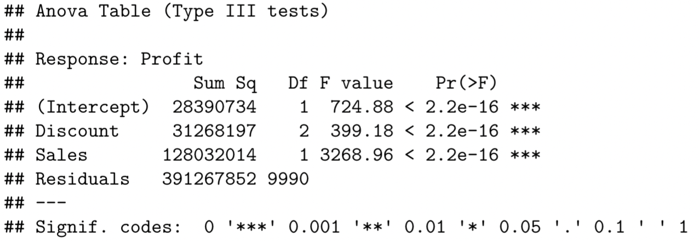

From this result, we can conclude that no matter we control discount or sales still, the other variable is

significant in this model, which indicates that they will significantly contribute to the model. From two significant p-value of Discount and Sales, we may say that: (1) Different Discount will influence the relationship between Sales and Profit.

(2) Sales does have relationship to profit.

Now we know that different discount influence the relationship between Sales and Profit, furthermore, we want to know how they influence the relationship between them, therefore, we did a regression, here is the result:

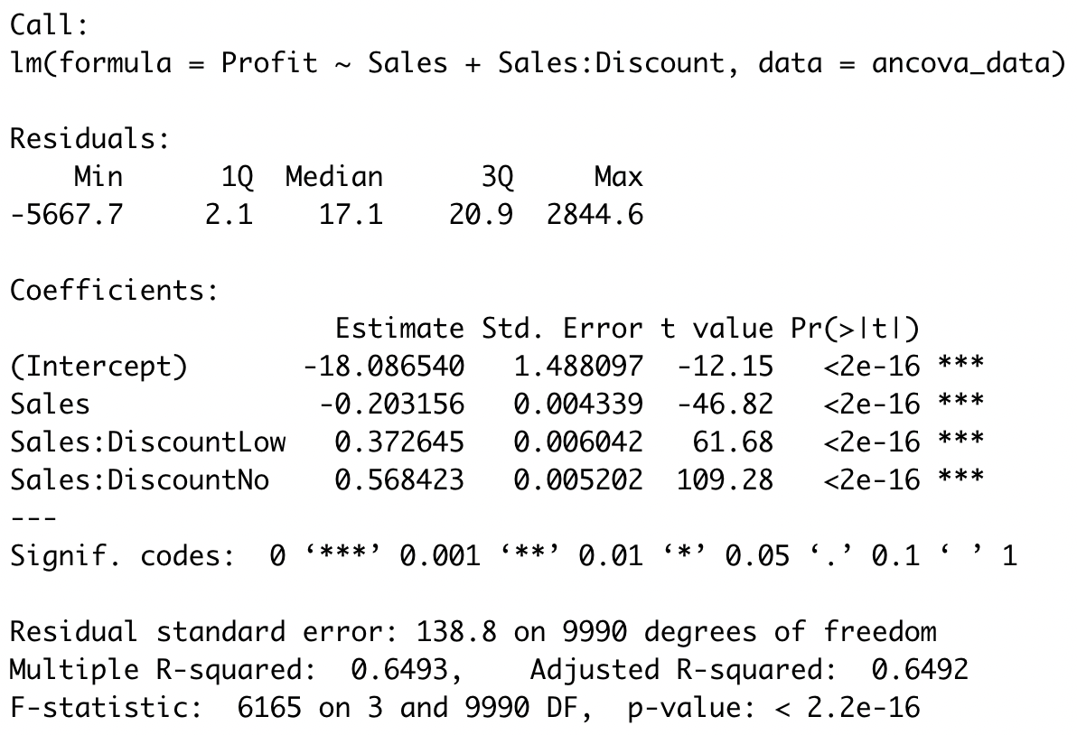

From this linear model with interaction of Sales and Discount, we may say that different discount will contribute different relationship between Sales and Profit. When discount is 0, the coefficient is 0.5684-0.2032=0.3652; When discount is low, the coefficient is 0.3726-0.2032=0.1694; When discount is high, the coefficient is -0.2032.

Here on the right side we made two pie charts.

The percentage of high discount products is the lowest, which is 13.94%. And most of the high discount products are office suppliers and furniture. We think that the superstore is cleaning the inventory, therefore those products were sold below the cost.

* + RFM analysis

Since we have Order.Date, Customer.ID, Orders and Sales, we think we can do a RFM analysis to segment our customers and see whether our customers are active in 2016-2017.

* **Summary and final conclusions of the project**
  + Marketing
  + Customers
* **Suggestions for going beyond the project.**

